

|  |
| --- |
| [Version 1.0]  **Last saved by: Ben McGregor**  **Last saved on:** 14/10/2014 |

|  |
| --- |
| Android application design |
| 11/10/2014 |
| **Ben McGregor**  CO600: JustHealth Supervisor: Yang He |

# 1.0 Overview

In order to produce a high quality application that fulfils the requirements outlined, it’s important to have designs that give an idea of what an appropriate final result might look like.

The initial designs are likely to be updated throughout the project, especially when developing iteratively within the agile development method. They are primarily created so the appearance and colours are decided on before implementation starts.

This document will include an overview of the initial designs for the JustHealth android application.

# 2.0 Designs

These designs have been produced using mock-up design software, Balsamiq (<https://balsamiq.com/>)

Logo positioning, page headers and footers, colour schemes and fonts will be uniform throughout the pages.

## 2.1 Application start-up

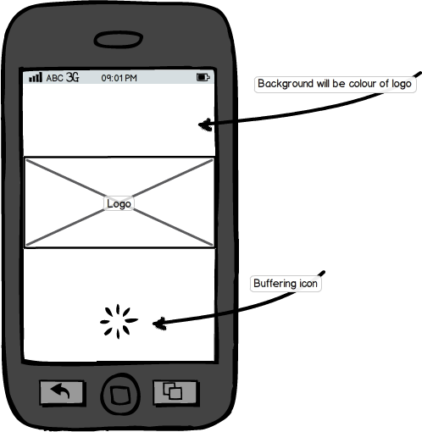

* The application start up screen will be the same colour as the logo background (#2272EB)
* The logo will appear across the centre of the screen full width – either just the image, or both image and ‘JustHealth’
* The buffering/loading icon will appear at the bottom (centre) of the screen, spinning.

## 2.2 User log in

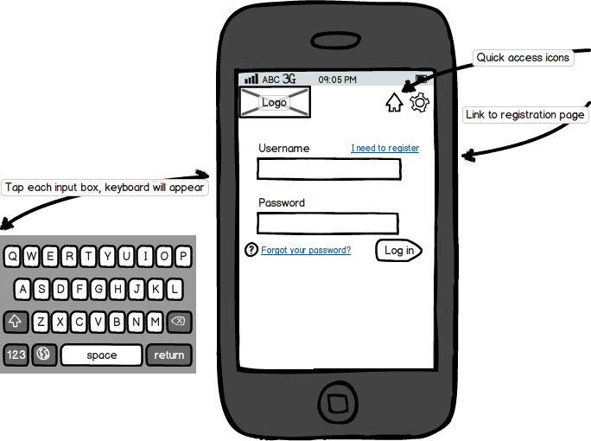

* The JustHealth logo will stay in the upper-left corner of the screen at all times, with the header of the screen based on the colour of the logo background.
* Quick access icons will be the same colour as the JustHealth logo font
* Page backgrounds will all be a shade of light-grey, text fields will be in white with all page content black.
* Buttons will be uniform in size
* Links will be clearly visible
* When the user presses on a text field, the device’s native keyboard will show

## 2.3 Register user

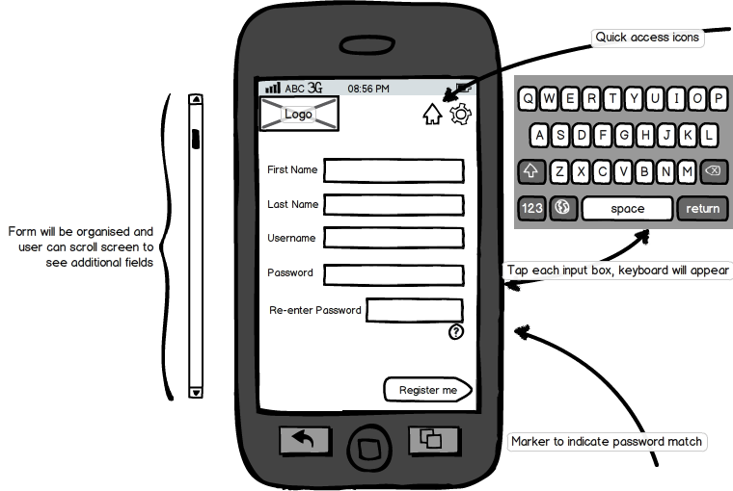

* The form fields must be uniform in size and colour, location on the page will be controlled. The user will be able to scroll to show any additional fields.
* The ‘Register’ button will show at the bottom of the form
* The quick access buttons will stay in the top-right corner
  + ‘Home’ icon will navigate back to log in screen
* When the user presses on a text field, the device’s native keyboard will show

## 2.4 Home screen

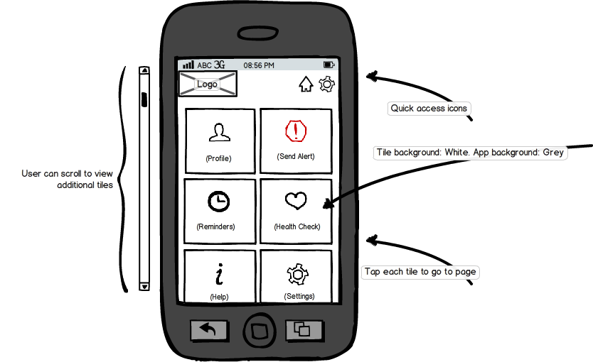

* Tiles will be uniform; prioritised and organised on the page
* Tile icons will be centred and clear to the user
* Once the user has logged in, this will become the redirect location for the ‘Home’ quick access icon
* User will be able to scroll on the screen to view additional icons
* Pressing back here will show the exit screen

## 2.5 Standard page

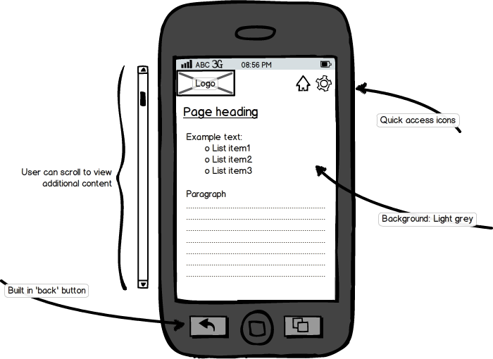

* Quick access icons to be in white to look similar to logo text
* ‘Back’ button to return to home screen (user can also press quick access icons to return)
* Page content to follow QA guidelines.

## 2.6 Exit application

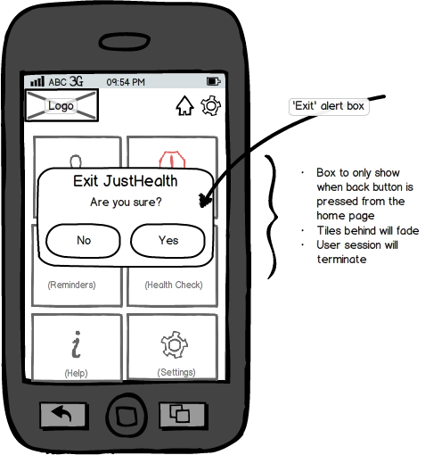

* Alert box will cause all tiles behind to fade (grey-out)
* Will open when native back button is pressed
* If back button is pressed with alert box showing, the box will disappear and JustHealth will remain open on the home page